Ansible is simple, open-source, configuration management tool used for IT

automation engine for cloud infrastructure, in-house servers.

Ansible push based configuration management system/tool

1. ansible does not require any dedicated agent running on the target host machines.

2. minimum ansible requirement is host machines with python installed on it.

3. we only require a proper ssh connection between the controller and the host machines.

Advantages:

1. free/open source

2. Very simple to setup

3. Agent less CM tool

**playbook**

- can contain n number of play

- each play is designated to run n number task

- each task is designated to execute a module (only one module per task)

**Ansible architecture**

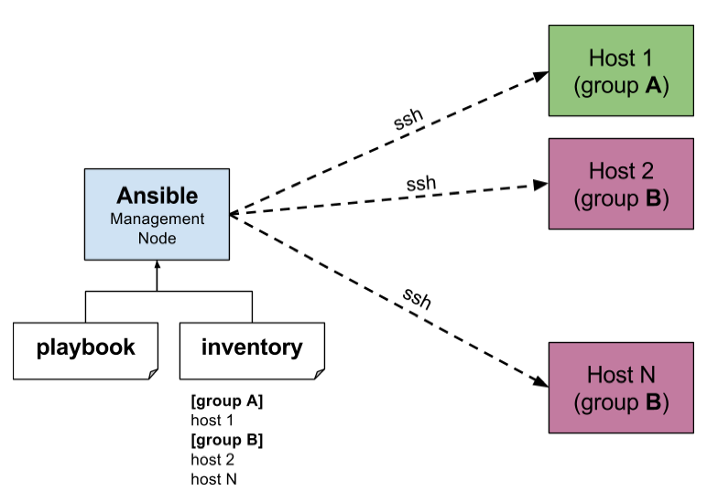

**Ansible configuration**

1. ANSIBLE_CONFIG (environment variable if set)

2. ansible.cfg (in the current directory)

3. ~/.ansible.cfg (in the home directory)

4. /etc/ansible/ansible.cfg

**Ansible Inventory Static Inventory**

- It is file which contains the ip and configuration of connection to target host machines on which

we want execute our playbooks

- we can group the hosts in inventory.

- default location of host file is /etc/ansible/hosts

- each line except group name is considered as a single host connection configuration.

[frontend]

13.233.104.27 ansible_user=ubuntu ansible_become_user=root

15.206.185.128 ansible_user=ubuntu ansible_become_user=root

[backend]

15.206.185.128 ansible_user=ubuntu ansible_become_user=root

**Dynamic Inventory**

- Is basically a script which will gives the inventory output.

- we can use python, perl, bash

**Ansible playbook**

---

- name: Play_2

hosts: backend

tasks:

- name: Install git (backend)

become: true

apt:

name: git

state: present

update_cache: yes

- name: Install jq (backend)

become: true

apt:

name: jq

state: latest

update_cache: yes

**commands**

$ ansible all -m pingx

$ ansible-playbook -k playbook1.yaml

$ ansible-playbook -k playbook1.yaml -i <inventory file>